**Q1)** The work function for platinum is 6.35eV. Ultraviolet light of wavelength 150 nm is incident on the clean surface of a platinum sample. We wish to predict the stopping voltage we will need for electrons ejected from the surface.

**(a)** What is the photon energy of the ultraviolet light?   
**(b)** How do you know that these photons will eject electrons from platinum?   
**(c)** What is the maximum kinetic energy of the ejected photoelectrons?  
**(d)** What stopping voltage would be required to arrest the current of photoelectrons?

1. F = C/ λ 🡪 3E8/150E-9 = 2E15 Hz

E = h f = 6.33E-34 * 2E15 = 1.326E-18   
 1.326E-18 * 1.602E -19 = 8.277 eV is the photon energy of UV light

b) because their energy is higher than the threshold energy of platinum

c) KE = hf – Φ 🡪 KE = 8.23 - 6.35 = 1.8 eV (multiply by 1.602E-19 to get it in joules = 3.012E-19 Joule)

d) 3.012E-19 eV = 1.602E-19 * V

V = 1.88 Volt

**Q2)**

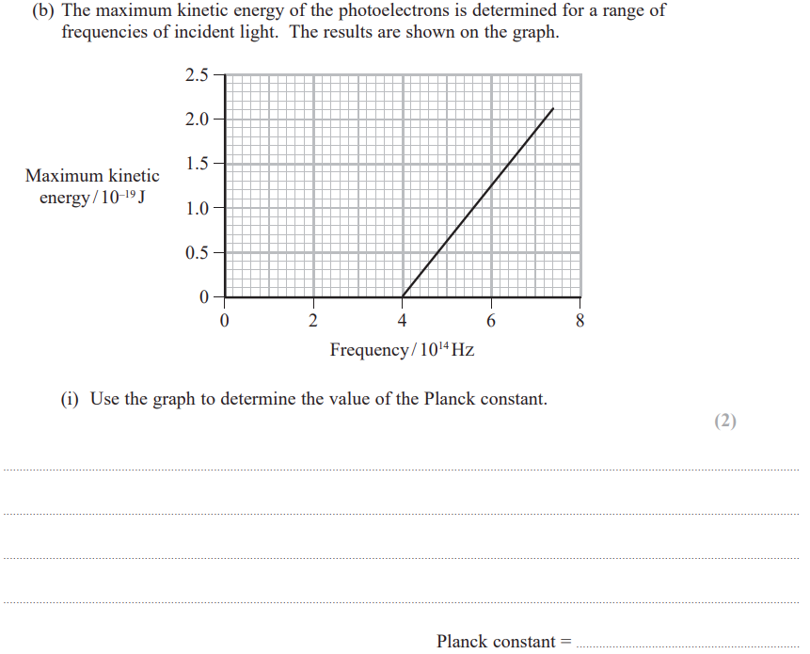

**Q3)**

